Novascan Ozone Chamber Instructions – Rev 2. Dave Bothman – 1 August 2018

Safety
- Check with lab staff before using the chamber for any purpose other than activating PDMS and glass.
- Make sure that the chamber is sealed before use.
- Ozone is a health hazard – if the unit is used outside of a fume hood the scrubber must be attached, and the chamber must be scrubbed for 10 minutes after the run has ended before opening it.
- Never disassemble or modify this unit.
- Do not open the lid during operation.
- Read the manual before using the unit. (link on lab website – microfluidics.cnsi.ucsb.edu).
- Check with lab staff if you have any questions before using the tool.

User checklist
- Open the chamber and place substrates on the platform.
- Check that the top of the substrate is less than 10 cm above the chamber base! See illustration below. Adjust the platform height by loosening the clamping screw on the right side of the base, and lowering or raising the platform as necessary. Tighten the screw to set the clamp.
- Close the chamber lid.
- Turn on the chamber lamps by hitting the start/stop switch. The timer is set to 10 minutes.
- Remove your substrates.
- Clean the chamber platform if necessary

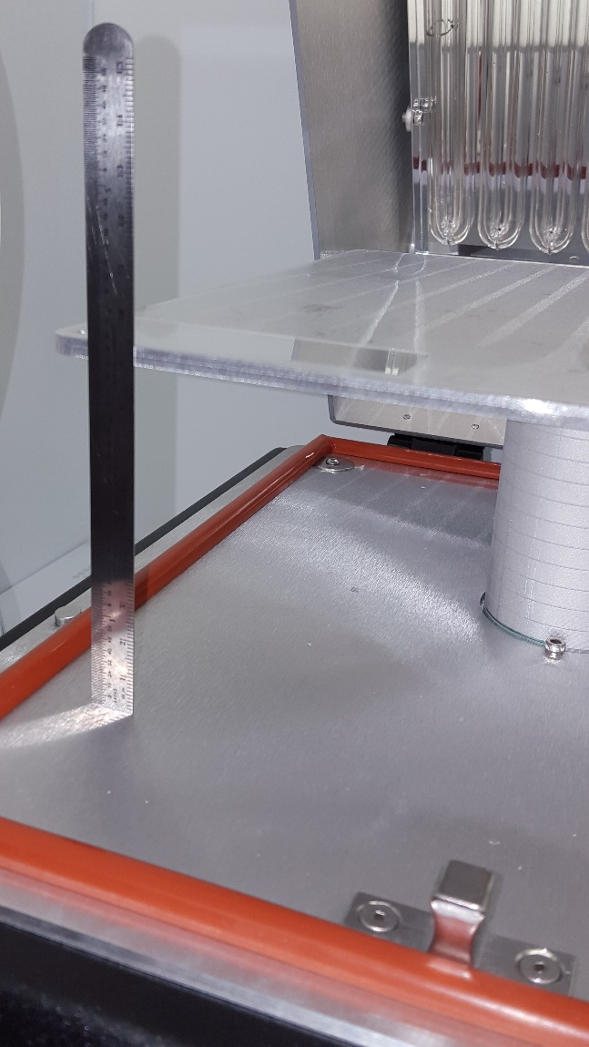
10 cm. max. to top of specimen

Important note: the UV bulb costs ~ $3,000 and is easily broken if it hits your specimen when you close the lid. Don’t forget to check the platform height!

