CNSI Innovation Workshop 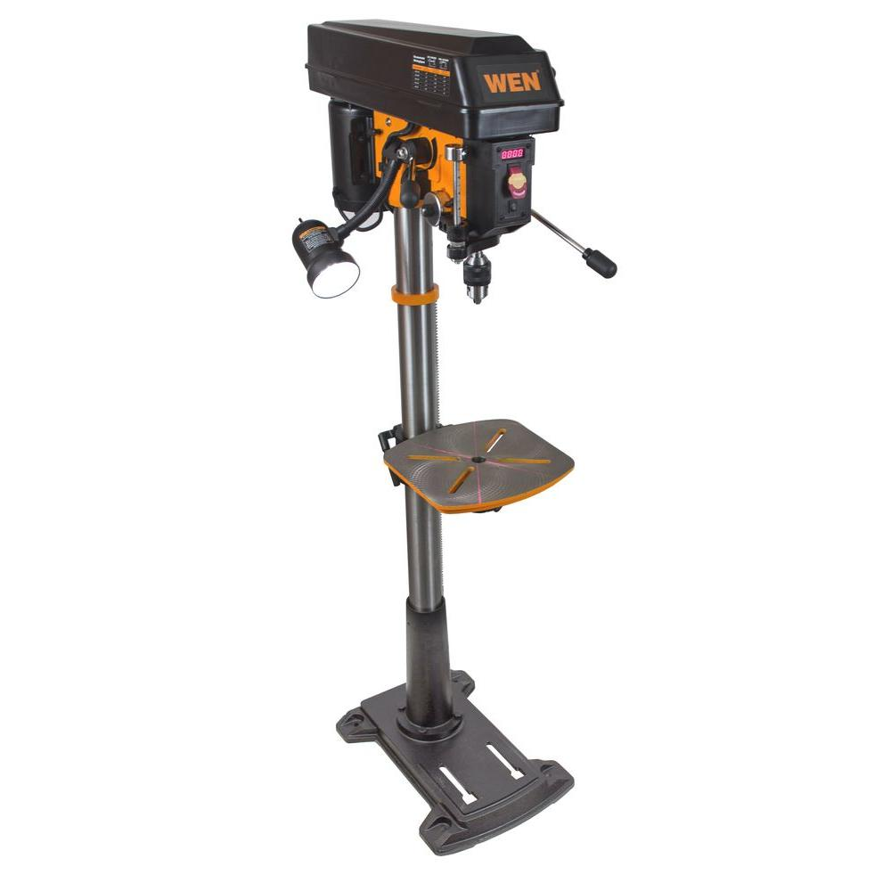
Drill Press Outline
Revised July 2019. Compiled with help from the UCSB ME Design Lab SOP written by Dr. Trevor Marks

Location
The Wen 15” Floor Standing Drill Press is located in 2448 Elings Hall

Safety Concerns
Eye injuries can result from flying chips or broken bits. Cuts can occur from contacting sharp tools or exposed chips and burrs. Burns can result from hot cutting tools or parts. Metal splinters can result from exposed burrs or chips. Serious injury can result from pinching or entanglement in moving parts. Poor housekeeping creates tripping and cutting hazards for other users. Do not leave machine running unattended.

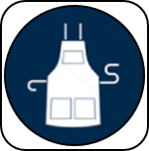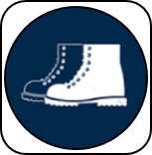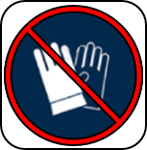
Eye protection, closed toe shoes, long pants, and protective clothing must be worn when using this machine to prevent injury. Long hair must be tied back and jewelry must be removed before operating this machine to prevent entanglement.

Training
Take and pass the Machine Shop Safety test found on the ME Labs GauchoSpace page, read the Drill Press document on the Innovation Workshop GauchoSpace page, attend the Innovation Workshop general machine tool training, and the Innovation Workshop drill press specific training before using this machine. Additional documents found on the GauchoSpace page.

Overview

User Guide

Safe Materials to Drill:
- Aluminum (Use lubricant)
- Brass (Use lubricant)
- Plastic (Do not use lubricant)
- Wood (Do not use lubricant)

Sequence of Operation:

Before Drilling:
- Check that you are complying with all PPE guidelines.
- Layout and center punch the holes you wish to drill
- Collect all necessary tools for your drilling operation. Inspect the tools to ensure that they are sharp and in good condition (Note: Do not use end mills or dremel bits in the drill press!)
- Insert the bit into the drill chuck, tighten with the chuck key, and remove the chuck key before continuing. Note: Do not tighten the chuck by powering on the machine and do not leave the chuck key in the chuck. These are both extremely dangerous and unsafe practices.
- Align the holes with the drill bit and secure the part using the vice or the drill bed clamp. Do not use custom fixtures or setups without first receiving permission from the lab staff, and especially do not hold the material with your hands.
- Adjust the work table to the appropriate height and lock securely.
- Check that the tool can spin freely and that it is clear of the part.
- Consult the chart to determine the proper feed rate and speed rate for the given hole/material. Adjust the machine to this speed.
- Remove all extra tools and parts from the drill press. Double check that everything is clear of rotating and moving parts.
- Apply cutting lubricant to the part.

Drilling:
- Turn the machine on (Do not leave running unattended).
- Use peck drilling operations to drill the hole, remove material in 0.05 inch increments.
- Remove chips and swarf using a brush. Do not use a rag or your bare hands to remove chips.
- Apply additional cutting fluid as necessary throughout the operation
- Reduce pressure when breaking through to prevent damage to the tool and part. Use backing board to prevent the part from blowing out.
- Power down the machine when done. Do not attempt to slow the machine down by hand.

After Drilling:
- Carefully remove the part and tool from the machine. Note: The tool and/or part may be hot, test before grabbing
- Use a brush and/or rag to clean up any chips, shavings, and oil from the drill press and the surrounding areas.
- Return all tools to their proper location and power down the drill press.Tidy up the work area.

Good Drilling Practices:
- Work from a drawing and project plan
- Properly layout the workpiece before beginning
- Use additional light to properly illuminate your workpiece
- Step up to larger drill sizes. The diameter of the smaller drill bit should be no thicker than the web (distance between flutes) of the larger drill bit.
- Use care when removing the tool from the chuck, support the tool with one hand so as not to drop it.

