Instructions for the SOH Lab CNC Mill and the dxf2fgc Conversion Program

Will Grover

Mathies Group, UC Berkeley
May 24, 2004

Revised and Updated by for UCSB Soh Lab by UCSB Capstone Team 19,2012

1 Introduction

If you're reading this to learn how to use the lab's mill and you don't much care about what is happening behind the scenes, skip ahead to the section entitled “Operation.” This document¹ was prepared to be applicable to dxf2fgc v1.20, LabVIEW v5.1, and FlashCut v1.61.

1.1 Theory of operation

Our application requires precise drilling of holes relative to features etched into glass wafers. There are two main approaches to solving this alignment problem:

Carefully align the etched wafer to the mill so that holes are drilled exactly in the locations specified by the CAD file, or

Arbitrarily place the etched wafer on the mill and use a camera to determine the location of the wafer relative to the mill's xed coordinates, then use this information to offset (rotate and translate) the hole coordinates in the CAD file so that the holes are drilled in the correct places on the otherwise arbitrarily-placed wafer.

The first method is suitable when the parts for drilling have features like edges or corners that cut into “jigs”; the resulting holes will be located accurately relative to the alignment features. Unfortunately, since the etched features in our wafers are usually not aligned to the wafer itself with any great precision, and since our wafers are round, placing the etched wafer in a “jig” for drilling does not adequately x the location or the angle of rotation of the wafer's features relative to the mill.

The second method of alignment (our chosen method) deemphasizes precise place-ment of the wafer in favor of careful measurement of the locations of two alignment marks on the wafer. The process of converting a DXF file (containing circles at the locations of the holes to drill) to a FGC file (encoding all the mill motions necessary for drilling the wafers) may be summarized as follows:

¹Please send any suggestions or corrections to wgrover@zinc.cchem.berkeley.edu

  - By using the drill bit to nick the surface of the wafer in an empty region, the height of the wafer surface in the Z -dimension of the mill's internal coordinate system is determined.

  - By sighting the nick in the camera, the offset between the drill bit and the camera crosshair in the XY plane of the mill's internal coordinate system is determined.

  - By using the camera to sight the locations of two alignment marks on the wafer, the locations of these two marks in the XY plane of the mill's internal coordinate system are determined.

  - The operator provides the locations of the alignment marks in the XY plane of the DXF file's coordinate system.

  - Using the two sets of coordinates for the alignment marks (one set relative to the mill/wafer system and the other relative to the DXF system), a two-part off-set (rotation and translation) between the DXF alignments and the mill/wafer alignments is calculated.

  - This offset is applied to the coordinates of each hole to be drilled in the DXF file, thereby converting their locations to the mill/wafer coordinate system.

  - The XY locations of the holes in the mill/wafer coordinate system are converted to “G code” instructions and combined with operations in the Z dimension that encode the “pecking” motions necessary for drilling glass. The resulting FGC file is saved for use by the mill's FlashCut software.

- Operation

2.1 Wafer preparation

Attach your wafer to a blank backing wafer with pine resin according to our usual drilling protocol². Scrape excess pine resin off the back of the backing wafer to improve the seal on the mill's vacuum chuck.

2.2 Preparation of DXF file(s)

The locations of circles in your DXF file(s) are used to determine where to drill holes in your wafer. The radius, layer, and other parameters of the circles are irrelevant to the conversion program–all circles present in a given DXF file will be drilled; other

²Place a blank backing wafer on an aluminum foil-covered hotplate and sprinkle ground pine resin over the wafer's surface. When the resin has melted place the etched wafer on the backing wafer and gently press the bubbles out of the trapped layer of pine resin. I prefer to place the wafer with etched features facing up so that the etched features and the drilled nick will both lie in the same focal plane and will be easy to sight accurately with the camera. Lift the wafers off the hotplate with the aluminum foil and continue to press the wafers together as the resin cools. Any bubbles remaining at the locations of drilled holes may cause wafer breakage when those holes are drilled.

shapes like lines or polylines will be ignored. Remember to remove any big circles representing the outline of your wafer (unless you want a hole drilled in the center of your wafer!). If you use AutoCAD for designing masks, run a purge command to eliminate any empty blocks, layers, etc. (they confuse the dxf2fgc program)³.

Export your mask as DXF files (any of the DXF formats will work) and save them to a oppy. You should have one DXF file for each drill bit that you plan to use, containing only the circles/holes that you plan to drill with that bit. For example, say you have a wafer with 100 large holes and 40 small holes. If you want to drill 50 large holes per bit (using two large bits in the process) and 40 small holes per bit (using only one small bit in the process), you'll need a total of 3 DXF files with names and contents something like this:

- bigbit1.dxf includes circles at locations of first 50 big holes

- bigbit2.dxf includes circles at locations of remaining 50 big holes

- smlbit1.dxf includes circles at locations of all 40 small holes

This may sound like a lot of work but you only have to generate these DXF files once for a given mask and drilling regime. The dxf2fgc program will accept DXF

files with a scale of either 1 mm/unit or 1 m/unit. Try to limit the filenames to the traditional DOS “8.3” limits (eight character filename plus .DXF) because the FlashCut program is unable to read longer filenames.

You'll also need to know the DXF file coordinates of two alignment marks from your wafer. For greatest alignment accuracy, the two alignment marks should be as far apart as possible, ideally straight across from each other (left to right across the wafer), and should be clearly visible on the etched wafer. Using a Sharpie pen to draw a circle around tiny alignment marks will you nd the marks under the camera. Circles for drilling can be used as one or both of the alignment marks, but it can be dif cult to align to large circles.

- Starting the CNC mill

  - Check your email to make sure that no mill-related problems have been reported. See the Notes section for more details.

  - Turn on the two power supply/controller boxes lying behind the CNC mill. Turn on the computer if it isn't already on. The electrical connection between the computer and the LCD screen is shaky and if the screen freezes or turns white, bend the screen back and forth until the screen works again.

  - Run the program FlashCut CNC (shortcut on the desktop). When asked whether the program should establish a connection to the signal generator, click Yes, then click Agree, then click Yes when asked whether to run backlash compensation.

  - Check the breadboard around the CNC mill and make sure nothing is obstructing the path of the mill. The screen should look like Figure 1.

³If you don't use AutoCAD, read the Notes section for information about writing your own DXF file from scratch.

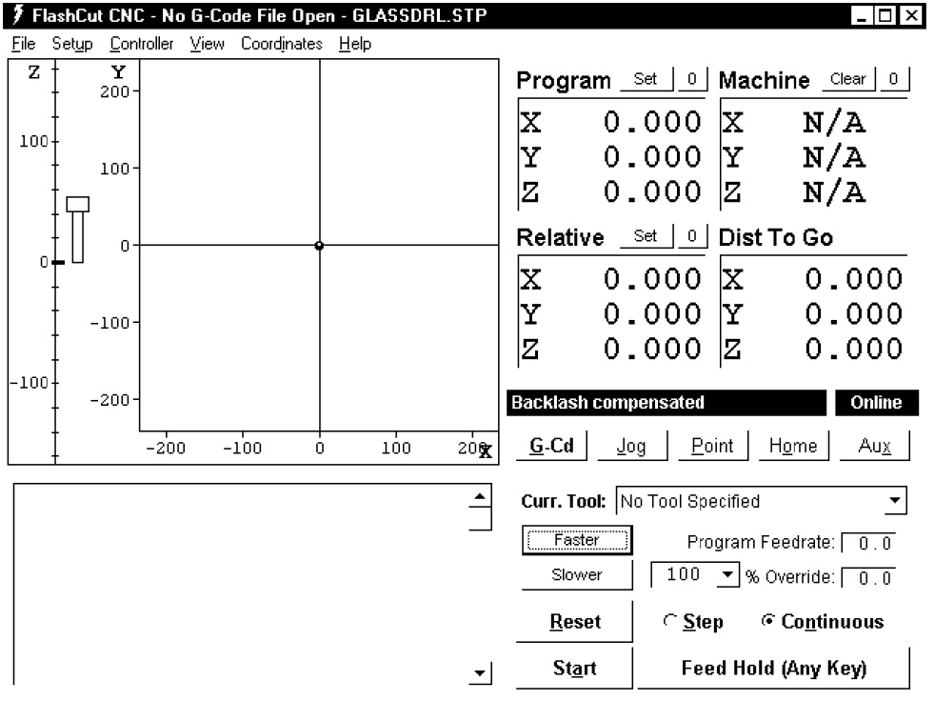

Figure 1: FlashCut program after startup and before homing the mill

  - Click Home, then Seek home. The mill will move each of the three axes one at a time to the limit, then backtrack each a little to (0; 0; 0) in the machine coordinates.

  - Important: when the CNC mill has stopped moving, click the 0 next to the Pro-gram coordinates to zero the program coordinates. These program coordinates should always agree with the machine coordinates, as shown in Figure 2. You can also zero the relative coordinates so that all three coordinate systems are in agreement.

- Loading your wafer

Place the wafer on the chuck so that the first alignment mark is to the left of the second alignment mark and the line between the two alignment marks makes approximately a 45 angle with the horizontal (x) axis (see Figure 3). The exact angle is not critical, but it is important for this angle to be somewhere between 0 and 90 . This is necessary because the conversion program requires that the both the sine and the cosine of this angle be greater than zero. An angle close to 45 will minimize any errors introduced in the conversion process. Now connect the vacuum line to the chuck. You may need to turn on the valve on the Raman lab bench across from our hotplate/oven bench. The wafer should now be stuck firmly to the top of the vacuum chuck. Install your drill bit

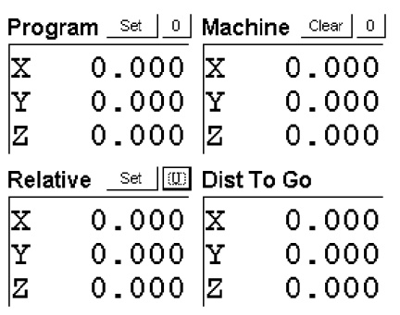

Figure 2: FlashCut program after seeking home and zeroing Program and Relative coordinates

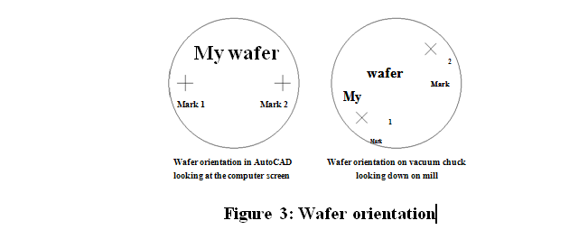
in the chuck and make sure the bit is centered in the chuck by watching the bit while rotating the chuck by hand.

2.5a Converting your DXF file for a circular wafer using alignment marks.

Start the dxf2fgc program and select the circular wafer with alignment marks tab, as shown in Figure 4. Converting your first DXF file takes longer than the remaining files because some a number of alignment steps must be performed. On subsequent DXF conversions (for subsequent drill bits) only a single parameter must be adjusted; see Converting subsequent DXF files

- Important: notice that when the mill is in the home position, the vacuum chuck is very close to the pillar that supports the Z axis. When the mill is in this position,

first move the chuck out (+y) clear of the pillar before moving the chuck left

(+x). Clicking +x when the mill is homed will drive the chuck into the pillar and damage the mill! So...

- Using the jog controls in the FlashCut program as shown in Figure 5, use (+y) first, then use the remaining jog controls to position the drill bit near the surface of the wafer in a region that can be nicked without hurting the final device. Place a drop or two of milling fluid on the wafer beneath the bit.

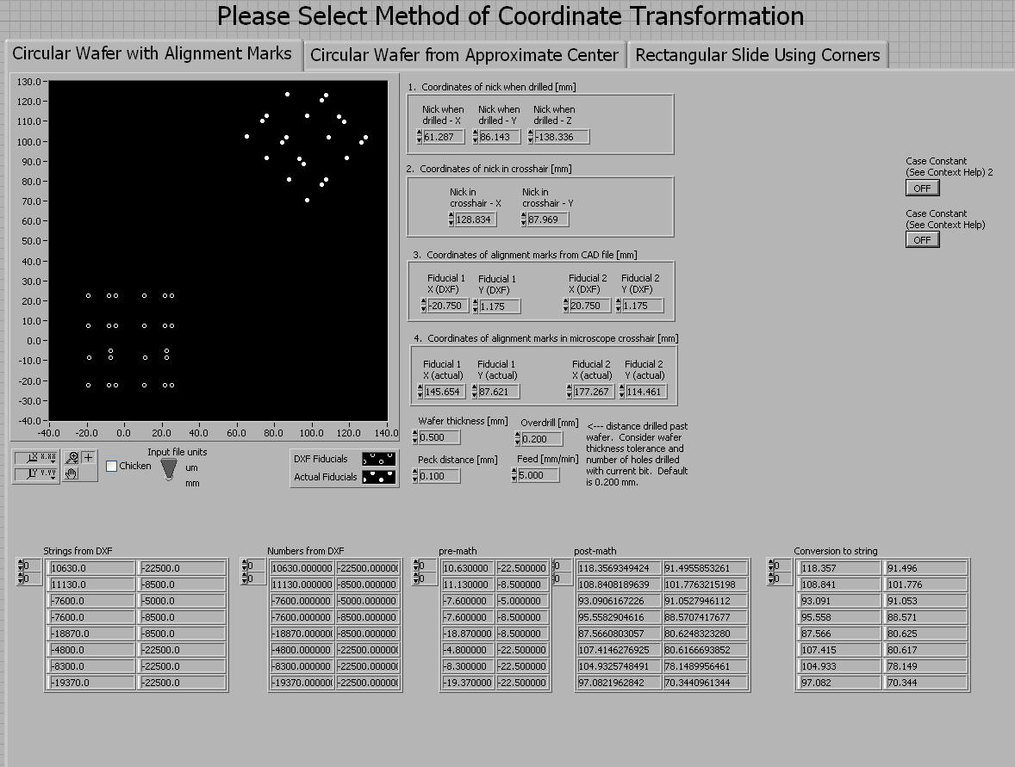

Figure 4: LabVIEW interface for a circular wafer with alignment marks

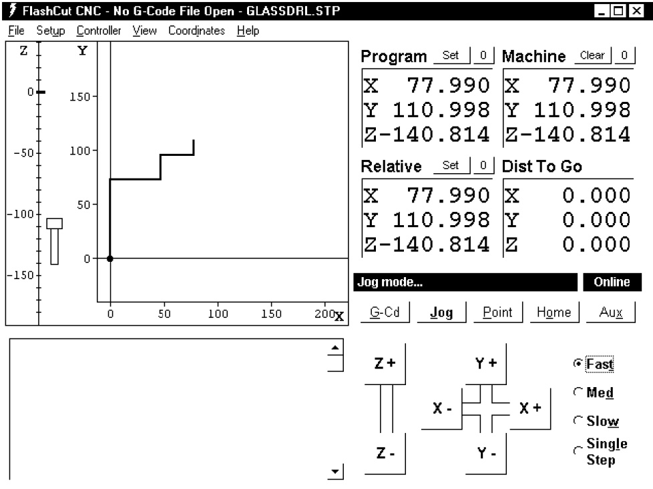

Figure 5: FlashCut window after jogging to nick position

- Turn on the drill motor switch and gently ramp the speed up to the highest set-ting. Using single mouse-clicks on the medium speed, slowly bring the bit down until it enters the fluid drop and just touches the surface of the wafer (a tiny plume of glass milk will be seen when the rotating bit contacts the wafer surface). Immediately turn down the drill speed and turn off the drill, and transfer the current (x; y; z) coordinates to Box 1 (“Coordinates of nick when drilled”) on the dxf2fgc program. Carefully jog the Z axis in the positive direction (up) clear of the wafer before proceeding.

- Use the Jog controls in the FlashCut program to move the drilled nick to the crosshair of the camera. You might want to use the center point (1.5) of the 3.0-unit ruler as the crosshair. Adjust the focus and position of the camera as

necessary, but after this step the position and focus of the camera should be left unchanged. The camera should be placed as close as is safely possible to the pulley and drilling head mounted on the Z axis. When the nick is centered on the crosshair, transfer the (x; y) coordinates to Box 2 (“Coordinates of nick in crosshair”) on the dxf2fgc program, and be careful not to bump, change the focus of, or otherwise disturb the camera from this point on!

- Fill in the DXF file coordinates of the two alignment marks in Box 3 (“Coordinates of alignment marks from CAD file”) on the dxf2fgc program. These are the coordinates of the two alignment marks as read directly from your original CAD file.

- Use the Jog controls to move the first alignment mark to the crosshair of the

camera. Transfer the (x; y) coordinates to Box 4 (“Coordinates of alignment marks in camera crosshair”) on the dxf2fgc program. Now use the Jog controls to move the second alignment point to the crosshair of the camera and transfer these (x; y) coordinates to Box 4 as well.

  - Set the remaining controls on the dxf2fgc program to your desired values. Set the Input file units switch to either “mm” or “ m” depending upon the units of your input DXF file. Specify the thickness of the wafer you are drilling. The overdrill is the distance drilled on each hole past the top wafer and into the backing wafer. Naturally this distance should be more than 0 (to guarantee that the top wafer has been drilled completely) but less than the thickness of the backing wafer. A typical value of 200 m should be increased to 400 or 500 m for runs requiring a large number of holes to be drilled with a single bit. Currently we are drilling 0.1 mm per peck with a feed rate of 5 mm/min during drilling and an overdrill of 200 to 500 m.

  - When all values on the dxf2fgc program are correct, run the program by clicking the arrow button in the upper-left corner of the screen. The program will ask for the location of the DXF file you're converting; specify the first DXF file you plan to drill. The program will then ask you to name the output FGC file; assign a name that associates the FGC file with the source DXF file. The program will also plot both the original DXF coordinates (open circles) and the new machine-based coordinates (filled circles) for the holes to be drilled. Make sure that the angle of rotation of the machine holes on the screen resembles the actual angle of rotation of your wafer. You may even want to use the Jog controls on the Flash-Cut program to move the bit to the location of a hole on the wafer and check the (x; y) coordinates of this point against the approximate coordinates for the hole read from the plot on the dxf2fgc program.

  - IMPORTANT – when you're done, don't close the convert program. If you have additional DXF files to convert later, you'll reuse most of the values you entered. If you close the program those values will be lost!

2.5b Converting your DXF file for a circular wafer that is referenced to the approximate center of the wafer

A new feature added to the UCSB system allows you to begin drilling without having to use alignment marks. Please only use this method if there are no pre-existing features located on your circular wafer. This method uses the assumption that the center of the vacuum chuck is fixed, so the mill skips the need for alignment marks and jogs straight to the approximate center of the wafer and begins to drill. See section 2.4 for loading your wafer and try to center the wafer as close as possible by inspection. Select the circular wafer from approximate center tab on DXF2FGC.

- Important: notice that when the mill is in the home position, the vacuum chuck is very close to the pillar that supports the Z axis. When the mill is in this position, first move the chuck out (+y) clear of the pillar before moving the chuck left (+x). Clicking +x when the mill is homed will drive the chuck into the pillar and damage the mill! So...

- Using the jog controls in the FlashCut program as shown in Figure 5, use (+y) first, then use the remaining jog controls to position the drill bit near the surface of the wafer in a region that can be nicked without hurting the final device. Place a drop or two of milling fluid on the wafer beneath the bit.

- Turn on the drill motor switch and gently ramp the speed up to the highest setting. Using single mouse-clicks on the medium speed, slowly bring the bit down until it enters the fluid drop and just touches the surface of the wafer (a tiny plume of glass milk will be seen when the rotating bit contacts the wafer surface). Immediately turn down the drill speed and turn off the drill, and transfer the current z coordinates to Box 1 (“Coordinates of nick when drilled”) on the dxf2fgc program. Carefully jog the Z axis in the positive direction (up) clear of the wafer before proceeding.

- When all values on the dxf2fgc program are correct, run the program by clicking the arrow button in the upper-left corner of the screen. The program will ask for the location of the DXF file you're converting; specify the first DXF file you plan to drill. The program will then ask you to name the output FGC file; assign a name that associates the FGC file with the source DXF file. The program will also plot both the original DXF coordinates (open circles) and the new machine-based coordinates (filled circles) for the holes to be drilled. Make sure that the angle of rotation of the machine holes on the screen resembles the actual angle of rotation of your wafer. You may even want to use the Jog controls on the Flash-Cut program to move the bit to the location of a hole on the wafer and check the (x; y) coordinates of this point against the approximate coordinates for the hole read from the plot on the dxf2fgc program.

- IMPORTANT – when you're done, don't close the convert program. If you have additional DXF files to convert later, you'll reuse most of the values you entered. If you close the program those values will be lost!

See section 4.1 for resetting the center of the vacuum chuck

2.5c Converting your DXF file for a rectangular microscope sliding using the corners as alignment marks.

Start the dxf2fgc program and select the rectangular slide tab, as shown in Figure 4. Converting your first DXF file takes longer than the remaining files because some a number of alignment steps must be performed. On subsequent DXF conversions (for subsequent drill bits) only a single parameter must be adjusted; see Converting subsequent DXF files

- Important: notice that when the mill is in the home position, the vacuum chuck is very close to the pillar that supports the Z axis. When the mill is in this position,

first move the chuck out (+y) clear of the pillar before moving the chuck left

(+x). Clicking +x when the mill is homed will drive the chuck into the pillar and damage the mill! So...

- Using the jog controls in the FlashCut program as shown in Figure 5, use (+y) first, then use the remaining jog controls to position the drill bit near the surface of the wafer in a region that can be nicked without hurting the final device. Place a drop or two of milling fluid on the wafer beneath the bit.

- Turn on the drill motor switch and gently ramp the speed up to the highest set-ting. Using single mouse-clicks on the medium speed, slowly bring the bit down until it enters the fluid drop and just touches the surface of the wafer (a tiny plume of glass milk will be seen when the rotating bit contacts the wafer surface). Immediately turn down the drill speed and turn off the drill, and transfer the current (x; y; z) coordinates to Box 1 (“Coordinates of nick when drilled”) on the dxf2fgc program. Carefully jog the Z axis in the positive direction (up) clear of the wafer before proceeding.

- Use the Jog controls in the FlashCut program to move the drilled nick to the crosshair of the camera. You might want to use the center point (1.5) of the 3.0-unit ruler as the crosshair. Adjust the focus and position of the camera as necessary, but after this step the position and focus of the camera should be left unchanged. The camera should be placed as close as is safely possible to the pulley and drilling head mounted on the Z axis. When the nick is centered on the crosshair, transfer the (x; y) coordinates to Box 2 (“Coordinates of nick in crosshair”) on the dxf2fgc program, and be careful not to bump, change the focus of, or otherwise disturb the camera from this point on!

- Fill in the DXF file coordinates of the two corners in Box 3 (“Coordinates of alignment marks from CAD file”) on the dxf2fgc program. These are the coordinates of the corners as read directly from your original CAD file.

- Use the Jog controls to move the first corner to the crosshair of the
camera. Transfer the (x; y) coordinates to Box 4 (“Coordinates of corners camera crosshair”) on the dxf2fgc program. Now use the Jog controls to move the second corner to the crosshair of the camera and transfer these (x; y) coordinates to Box 4 as well.

- Set the remaining controls on the dxf2fgc program to your desired values. Set the Input file units switch to either “mm” or “ m” depending upon the units of your input DXF file. Specify the thickness of the wafer you are drilling. The overdrill is the distance drilled on each hole past the top wafer and into the backing wafer. Naturally this distance should be more than 0 (to guarantee that the top wafer has been drilled completely) but less than the thickness of the backing wafer. A typical value of 200 m should be increased to 400 or 500 m for runs requiring a large number of holes to be drilled with a single bit. Currently we are drilling 0.1 mm per peck with a feed rate of 5 mm/min during drilling and an overdrill of 200 to 500 m.

- When all values on the dxf2fgc program are correct, run the program by clicking the arrow button in the upper-left corner of the screen. The program will ask for the location of the DXF file you're converting; specify the first DXF file you plan to drill. The program will then ask you to name the output FGC file; assign a name that associates the FGC file with the source DXF file. The program will also plot both the original DXF coordinates (open circles) and the new machine-based coordinates (filled circles) for the holes to be drilled. Make sure that the angle of rotation of the machine holes on the screen resembles the actual angle of rotation of your wafer. You may even want to use the Jog controls on the Flash-Cut program to move the bit to the location of a hole on the wafer and check the (x; y) coordinates of this point against the approximate coordinates for the hole read from the plot on the dxf2fgc program.

- IMPORTANT – when you're done, don't close the convert program. If you have additional DXF files to convert later, you'll reuse most of the values you entered. If you close the program those values will be lost!

- Running the generated FGC code

Switch to the FlashCut program and select File, Open G-code. Select the FGC file that you just generated, as shown in Figure 6. Start the drill motor, gently immerse the regions of the wafer to be drilled in a little puddle of lubricating fluid, and click G-cd, Start on the FlashCut program. Keep an eye on the mill as it runs and remember that hitting any key on the computer keyboard will instantly stop the mill's motion. If you notice anything strange, press any key to stop the mill and then stop the drilling motor before inserting your hands or your head into the enclosure to investigate the problem. To restart the mill after stopping mid-program, restart the motor and then click start on the FlashCut program.

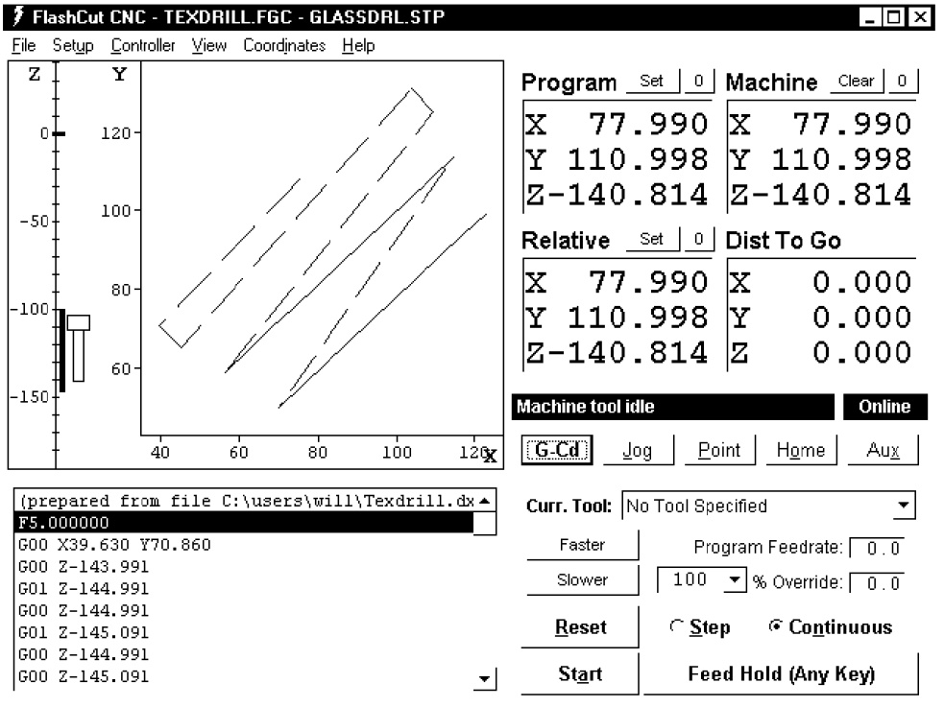

Figure 6: FlashCut window after opening the generated FGC file

2.7 Converting subsequent DXF files

Once you have finished drilling the holes in the first DXF/FGC combination, if you have remaining files/bits, change to your next bit and use the FlashCut Jog controls to nick the wafer again. Turn off the drill with the bit in contact with the wafer and this time transfer only the Z coordinate to Box 1 of the convert program. Then back the drill off from the surface (+Z ) as usual. All other coordinates on the program should still be correct from the first DXF conversion. Now run the dxf2fgc program on your second DXF file and you'll create your second FGC file, ready to run in the FlashCut program. Continue this alternating process until all your DXF files are converted and all your holes are drilled.

2.8 Shutdown

Aspirate the water from your wafer and remove the wafer from the chuck. For good karma, home the mill once more so that the next user's homing operation will be quick. Close the FlashCut and dxf2fgc programs but leave the computer on, then turn off the two power switches on the CNC mill control boxes and you're done!

3 Notes

3.1 Mill communication

All mill users are added to a mailing list with the address

mill@zinc.cchem.berkeley.edu

If you encounter any problems while running the mill or have any general comments to make, send an email to the list. If the problem is “fatal,” flip over the sign on the mill enclosure. Fixes and other mill-related info will be communicated through the list.

3.2 Mill maintenance

We lubricate the mill's lead screws and axes every 500 holes drilled (which happens pretty quickly). Here is the protocol:

  - Home the mill and zero the program coordinates.

  - Wipe away any visible gobs of old lubricant from the lead screws and axis surfaces. The X -axis is inverted and dif cult to reach, but a quick wipe beneath the axis with a Technicloth should surface.

  - Apply a small amount of lubricant onto the leadscrews and the axis surfaces.

  - Jog the three mill axes nearly to their limits.

  - Wipe away any excess lubricant from the leadscrews and axis surfaces.

  - Home the mill again. Any discrepancies between the two home operations will be reported. If the discrepancies reported are significant (more than a few microns) report the problem to mill@zinc.cchem.berkeley.edu

- Drilling blank wafers

Charlie Emrich suggests a good way to drill a pattern of holes in an otherwise unfeatured wafer:

I measured the diameter of the holes on the wafer stage to be 12.1 cm [these holes are on the edge of the vacuum chuck and are still visible when the wafer is loaded]. From there, I just popped a wafer on, nicked it (recording the nick position), aligned to the nick and two of the holes on the wafer stage [the holes chosen form a 45 angle with the X -axis, just like regular on-chip alignment marks]. The coordinates for the holes I used as the original position for the alignment marks (-60.5, 0 and 60.5, 0). This gave me enough to do quite a good job getting the pattern aligned to the wafer. I was accurate to probably within a millimeter.

3.4 Minimizing backlash errors

The mill's backlash compensation does a good job of reducing errors introduced when the X or Y axes reverse direction, but additional care may be required when precise tolerances are required. One way to further reduce the errors associated with backlash is to always load the screws in the same direction during the nick, nick sighting, and alignment mark sighting steps. For example, when sighting the nick, roughly position the crosshair to the left and below the nick, then switch to medium speed and jog +x and +y to approach the nick, and finally switch to slow speed and jog +x and +y to the nick location, without using x or y. This procedure ensures that all nick and sighting steps are made with the screws loaded in a uniform manner and reduces the error associated with the calculated hole locations.

3.5 Drilling without AutoCAD

If AutoCAD (or a similar program) wasn't used to design your wafer, but you know the relative coordinates of the hole locations plus two alignment marks and you want to use the mill, you can create your own DXF file without AutoCAD. The DXF format is a plain text file with a fairly straightforward syntax⁴. The string CIRCLE (all caps) marks the beginning of each circle's entry in the DXF file. Following CIRCLE, several

“group codes” specify the various parameters of the circle. The only ones that the dxf2fgc program searches for are 10, 20, and 30 ( represents a single space), which correspond to the x, y, and z coordinates of the circle in microns or millimeters. The value for the z field is actually ignored by dxf2fgc, but the program's parser requires that the 30 code be present to mark the end of the particular hole's entry in the DXF file. Here's a sample DXF file for drilling a hole at (x; y) coordinates

(20000; 30000):

CIRCLE 10
20000

20

30000

30

Notice the mandatory spaces before 10, 20, and 30. Add additional CIRCLE statements for the remaining holes and you'll have a DXF file ready for conversion by the dxf2fgc program.

3.6 Software reference

The dxf2fgc software consists of two parts: the main program dxf2fgc.vi and a sub-VI named cadlogic.vi. A handful of standard Lab VIEW sub-VIs are also called by the programs. I began work on the program in 2003 following the mill's initial setup with Dr. Eric Lagally.

⁴See http://www.autodesk.com/techpubs/autocad/acad2000/dxf for a DXF reference.

The program begins by opening the specified DXF file and reading the contents into a large string. A parser consisting of regular expression VIs inside a while loop is used to read the (x; y) locations of each hole to be drilled. The values in the resulting 2 by n array (where n is the number of holes to drill) are converted to millimeters if necessary and fed pairwise, one hole at a time, into the main for loop. This loop feeds the DXF hole coordinates plus the parameters specified on the front panel to the cadlogic.vi sub-VI, which returns the new coordinates of the hole in the mill's coordinate system. A large concatenation operation adds necessary G-code statements and builds a single large string which is finally saved as the output FGC file. The program maintains a usage log at c:ncnclog.txt; this default location can be changed in the diagram code.

4 System Maintenance

4.1 Resetting the location of the vacuum chuck

For a variety of reasons, the location of the vacuum chuck may change from its original location. This will result in the loss of functionality of the coordinate transformation as described in section 2.5c, because this method is dependent on the vacuum chuck location. Follow these steps in order to reprogram the location of the vacuum chuck inside of LabVIEW.

- Open dxf2fgc.vi and select the circular wafer from approximate center tab
- Open Flashcut
- Manually jog the spindle to the location of the approximate center of the vacuum chuck
- Find the reprogram center box located at the bottom of the VI screen, as shown
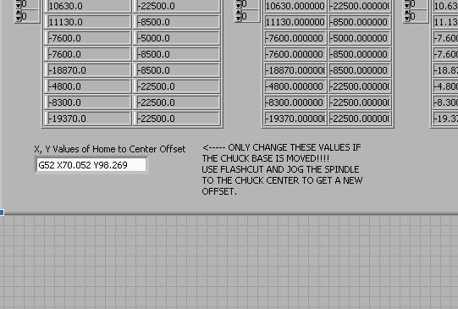
- Type in the x and y coordinates as shown on Flashcut, be careful to only change the coordinates, and leave the other formatting.

4.2 Replacing the camera

The camera model is an Oasis Scientific 2.0 MP, 8mm USB Digital Microscope, available from Amazon.com

4.3 Replacing the vacuum chuck heads

PURPOSE

This assembly instruction describes the assembly of the modified vacuum chuck with its matching replacement top plates.

REFERENCES

2.1 Assembly Drawings:

004-005RevB, Vacuum Chuck Assy

2.2 Part Drawings:

003-004RevA, Replacement Top Plate

010-003RevA, Replacement Plate Rectangular

013-001RevA, Chuck Base Final

RESPONSIBILITIES

3.1 The assembler is responsible for using the latest revision of this Assembly procedure listed in the commodity code database, unless otherwise directed by Dave Bothman.

REQUIRED EQUIPMENT
Tools
#6 (7/64”) Allen Key

Hardware
# needed | McMaster Part # | Description
2 | 91251A345 | Type 316 Stainless STL Socket Head Cap Screw 10-32 Thread, 3/4" Length

PROCEDURE FOR ASSEMBLY AND TEST

Follow procedures in sequential order as follows:
Section 1: Removal of current plate (if one is present)
Parts
1x 013-001RevA, Chuck Base Final
1x 010-003RevA, Replacement Plate Rectangular
OR
003-004RevA, Replacement Top Plate

Hardware
No additional hardware needed
2x (6-32 SHCS x .75” Long already in place)

Tools
#6 (7/64”) Allen Key

Background: This procedure will disassemble the chuck base (013-001RevA, Chuck Base Final) and any top plate in place (010-003RevA, Replacement Plate Rectangular OR 003-004RevA, Replacement Top Plate).

Step 1.1
Step 1.1)
Locate the 2 #10-32 screws where shown.

Items

1x 010-003RevA, Replacement Plate Rectangular
1x 013-001RevA, Chuck Base Final
2x 91251A345

Step 1.2
Step 1.2)
Unscrew as shown using #6 (7/64”) Allen Key.
Items

1x 010-003RevA, Replacement Plate Rectangular
1x 013-001RevA, Chuck Base Final
2x 91251A345
1x #6 (7/64”) Allen Key

Step 1.3

Section 2: Assembly of top plate once vice chuck top surface is exposed
Step 1.3)
Remove replacement plate as shown.

Items

1x 013-001RevA, Chuck Base Final
2x 91251A345

Parts
1x 013-001RevA, Chuck Base Final
1x 010-003RevA, Replacement Plate Rectangular
OR
003-004RevA, Replacement Top Plate

Hardware
No additional hardware needed
2x (6-32 SHCS x .75” Long already in place)

Tools
#6 (7/64”) Allen Key

Step 2.1
Step 2.1)
Switch replacement plates and line up the thru holes in the base with the threaded holes in the top plate (as shown).
Items
1x 013-001RevA, Chuck Base Final
1x 003-004RevA, Replacement Top Plate
2x 91251A345

Step 2.2

Step 2.2)
Screw in top plate as shown.
Items
1x 013-001RevA, Chuck Base Final
1x 003-004RevA, Replacement Top Plate
2x 91251A345
1x #6 (7/64”) Allen Key

