Microfluidics Lab Sherline / Flashcut CNC Mill assembly and maintenance

Revised and Updated by for UCSB Soh Lab by UCSB Capstone Team 19,2012

The program begins by opening the specified DXF file and reading the contents into a large string. A parser consisting of regular expression VIs inside a while loop is used to read the (x; y) locations of each hole to be drilled. The values in the resulting 2 by n array (where n is the number of holes to drill) are converted to millimeters if necessary and fed pairwise, one hole at a time, into the main for loop. This loop feeds the DXF hole coordinates plus the parameters specified on the front panel to the cadlogic.vi sub-VI, which returns the new coordinates of the hole in the mill's coordinate system. A large concatenation operation adds necessary G-code statements and builds a single large string which is finally saved as the output FGC file. The program maintains a usage log at c:ncnclog.txt; this default location can be changed in the diagram code.

4 System Maintenance

4.1 Resetting the location of the vacuum chuck

For a variety of reasons, the location of the vacuum chuck may change from its original location. This will result in the loss of functionality of the coordinate transformation as described in section 2.5c, because this method is dependent on the vacuum chuck location. Follow these steps in order to reprogram the location of the vacuum chuck inside of LabVIEW.

- Open dxf2fgc.vi and select the circular wafer from approximate center tab
- Open Flashcut
- Manually jog the spindle to the location of the approximate center of the vacuum chuck
- Find the reprogram center box located at the bottom of the VI screen, as shown
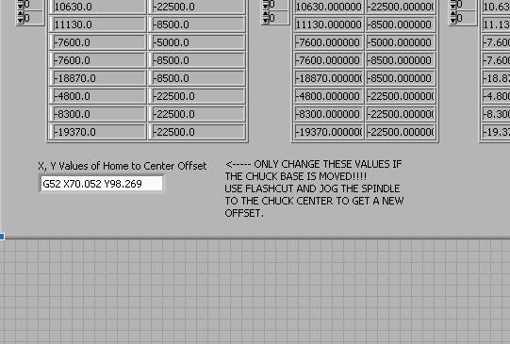
- Type in the x and y coordinates as shown on Flashcut, be careful to only change the coordinates, and leave the other formatting.

4.2 Replacing the camera

The camera model is an Oasis Scientific 2.0 MP, 8mm USB Digital Microscope, available from Amazon.com

4.3 Replacing the vacuum chuck heads

PURPOSE

This assembly instruction describes the assembly of the modified vacuum chuck with its matching replacement top plates.

REFERENCES

2.1 Assembly Drawings:

004-005RevB, Vacuum Chuck Assy

2.2 Part Drawings:

003-004RevA, Replacement Top Plate

010-003RevA, Replacement Plate Rectangular

013-001RevA, Chuck Base Final

RESPONSIBILITIES

3.1 The assembler is responsible for using the latest revision of this Assembly procedure listed in the commodity code database, unless otherwise directed by Dave Bothman.

REQUIRED EQUIPMENT
Tools
#6 (7/64”) Allen Key

Hardware
# needed | McMaster Part # | Description
2 | 91251A345 | Type 316 Stainless STL Socket Head Cap Screw 10-32 Thread, 3/4" Length

PROCEDURE FOR ASSEMBLY AND TEST

Follow procedures in sequential order as follows:
Section 1: Removal of current plate (if one is present)
Parts
1x 013-001RevA, Chuck Base Final
1x 010-003RevA, Replacement Plate Rectangular
OR
003-004RevA, Replacement Top Plate

Hardware
No additional hardware needed
2x (6-32 SHCS x .75” Long already in place)

Tools
#6 (7/64”) Allen Key

Background: This procedure will disassemble the chuck base (013-001RevA, Chuck Base Final) and any top plate in place (010-003RevA, Replacement Plate Rectangular OR 003-004RevA, Replacement Top Plate).

Step 1.1
Step 1.1)
Locate the 2 #10-32 screws where shown.

Items

1x 010-003RevA, Replacement Plate Rectangular
1x 013-001RevA, Chuck Base Final
2x 91251A345

Step 1.2
Step 1.2)
Unscrew as shown using #6 (7/64”) Allen Key.
Items

1x 010-003RevA, Replacement Plate Rectangular
1x 013-001RevA, Chuck Base Final
2x 91251A345
1x #6 (7/64”) Allen Key

Step 1.3

Section 2: Assembly of top plate once vice chuck top surface is exposed
Step 1.3)
Remove replacement plate as shown.

Items

1x 013-001RevA, Chuck Base Final
2x 91251A345

Parts
1x 013-001RevA, Chuck Base Final
1x 010-003RevA, Replacement Plate Rectangular
OR
003-004RevA, Replacement Top Plate

Hardware
No additional hardware needed
2x (6-32 SHCS x .75” Long already in place)

Tools
#6 (7/64”) Allen Key

Step 2.1
Step 2.1)
Switch replacement plates and line up the thru holes in the base with the threaded holes in the top plate (as shown).
Items
1x 013-001RevA, Chuck Base Final
1x 003-004RevA, Replacement Top Plate
2x 91251A345

Step 2.2

Step 2.2)
Screw in top plate as shown.
Items
1x 013-001RevA, Chuck Base Final
1x 003-004RevA, Replacement Top Plate
2x 91251A345
1x #6 (7/64”) Allen Key

